**Báo cáo Thực hành KTMT buổi 11**

**Họ và tên:** Nguyễn Đức Phú

**MSSV:** 20215116

**Assignment 1:**

1. Vẽ hình tam giác đều:

* Code:

.eqv HEADING 0xffff8010

.eqv MOVING 0xffff8050

.eqv LEAVETRACK 0xffff8020

.eqv WHEREX 0xffff8030

.eqv WHEREY 0xffff8040

.text

main:

addi $a0, $zero, 90

jal ROTATE

jal GO

sleep1:

addi $v0,$zero,32

li $a0,16000

syscall

jal UNTRACK

goDOWN:

addi $a0, $zero, 180

jal ROTATE

sleep2:

addi $v0,$zero,32

li $a0,9000

syscall

jal UNTRACK

jal TRACK

go120:

addi $a0, $zero, 150

jal ROTATE

sleep3:

addi $v0,$zero,32

li $a0,15000

syscall

jal UNTRACK

jal TRACK

goLEFT:

addi $a0, $zero, 270

jal ROTATE

sleep4:

addi $v0,$zero,32

li $a0,15000

syscall

jal UNTRACK

jal TRACK

go30:

addi $a0, $zero, 30

jal ROTATE

sleep5:

addi $v0,$zero,32

li $a0,15000

syscall

jal UNTRACK

goLEFT1:

addi $a0,$zero,270

li $a0,10000

syscall

jal STOP

end_main:

li $v0,10

syscall

#-----------------------------------------------------------

# GO procedure, to start running

# param[in] none

#-----------------------------------------------------------

GO: li $at, MOVING

addi $k0, $zero,1 # to logic 1,

sb $k0, 0($at) # to start running

jr $ra

#-----------------------------------------------------------

# STOP procedure, to stop running

# param[in] none

#-----------------------------------------------------------

STOP: li $at, MOVING

sb $zero, 0($at) # to stop

jr $ra

#-----------------------------------------------------------

# TRACK procedure, to start drawing line

# param[in] none

#-----------------------------------------------------------

TRACK: li $at, LEAVETRACK

addi $k0, $zero,1

sb $k0, 0($at)

jr $ra

#-----------------------------------------------------------

# UNTRACK procedure, to stop drawing line

# param[in] none

#-----------------------------------------------------------

UNTRACK: li $at, LEAVETRACK

sb $zero, 0($at)

jr $ra

#-----------------------------------------------------------

# ROTATE procedure, to rotate the robot

# param[in] $a0, An angle between 0 and 359

# 0 : North (up)

# 90: East (right)

# 180: South (down)

# 270: West (left)

#-----------------------------------------------------------

ROTATE: li $at, HEADING

sw $a0, 0($at)

jr $ra

* Kết quả chạy:

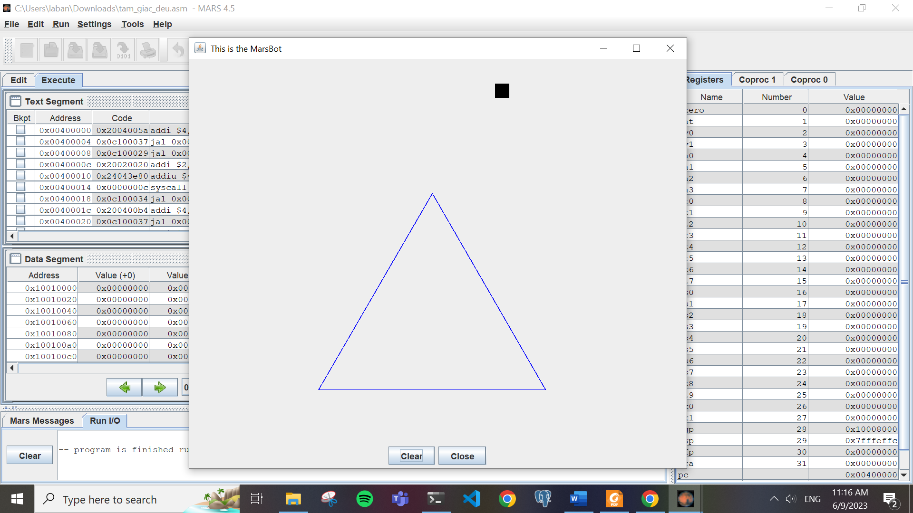

1. Vẽ hình vuông:

* Code:

.eqv HEADING 0xffff8010

.eqv MOVING 0xffff8050

.eqv LEAVETRACK 0xffff8020

.eqv WHEREX 0xffff8030

.eqv WHEREY 0xffff8040

.text

main:

addi $a0, $zero, 90

jal ROTATE

jal GO

sleep1: addi $v0,$zero,32

li $a0,7500

syscall

jal UNTRACK

goDOWN: addi $a0, $zero, 180

jal ROTATE

sleep2: addi $v0,$zero,32

li $a0,6000

syscall

jal UNTRACK

jal TRACK

goRIGHT: addi $a0, $zero, 90

jal ROTATE

sleep3: addi $v0,$zero,32

li $a0,10000

syscall

jal UNTRACK

jal TRACK

goDOWN1: addi $a0, $zero, 180

jal ROTATE

sleep4: addi $v0,$zero,32

li $a0,10000

syscall

jal UNTRACK

jal TRACK

goLEFT: addi $a0, $zero, 270

jal ROTATE

sleep5: addi $v0,$zero,32

li $a0,10000

syscall

jal UNTRACK

jal TRACK

goUP: addi $a0,$zero,0

jal ROTATE

sleep6: addi $v0,$zero,32

li $a0,10000

syscall

jal UNTRACK

goRIGHT1: addi $a0, $zero, 90

jal ROTATE

sleep7: addi $v0,$zero,32

li $a0,12000

syscall

jal STOP

end_main:

li $v0,10

syscall

#-----------------------------------------------------------

# GO procedure, to start running

# param[in] none

#-----------------------------------------------------------

GO: li $at, MOVING

addi $k0, $zero,1 # to logic 1,

sb $k0, 0($at) # to start running

jr $ra

#-----------------------------------------------------------

# STOP procedure, to stop running

# param[in] none

#-----------------------------------------------------------

STOP: li $at, MOVING

sb $zero, 0($at) # to stop

jr $ra

#-----------------------------------------------------------

# TRACK procedure, to start drawing line

# param[in] none

#-----------------------------------------------------------

TRACK: li $at, LEAVETRACK

addi $k0, $zero,1

sb $k0, 0($at)

jr $ra

#-----------------------------------------------------------

# UNTRACK procedure, to stop drawing line

# param[in] none

#-----------------------------------------------------------

UNTRACK: li $at, LEAVETRACK

sb $zero, 0($at)

jr $ra

#-----------------------------------------------------------

# ROTATE procedure, to rotate the robot

# param[in] $a0, An angle between 0 and 359

# 0 : North (up)

# 90: East (right)

# 180: South (down)

# 270: West (left)

#-----------------------------------------------------------

ROTATE: li $at, HEADING

sw $a0, 0($at)

jr $ra

* Kết quả chạy:

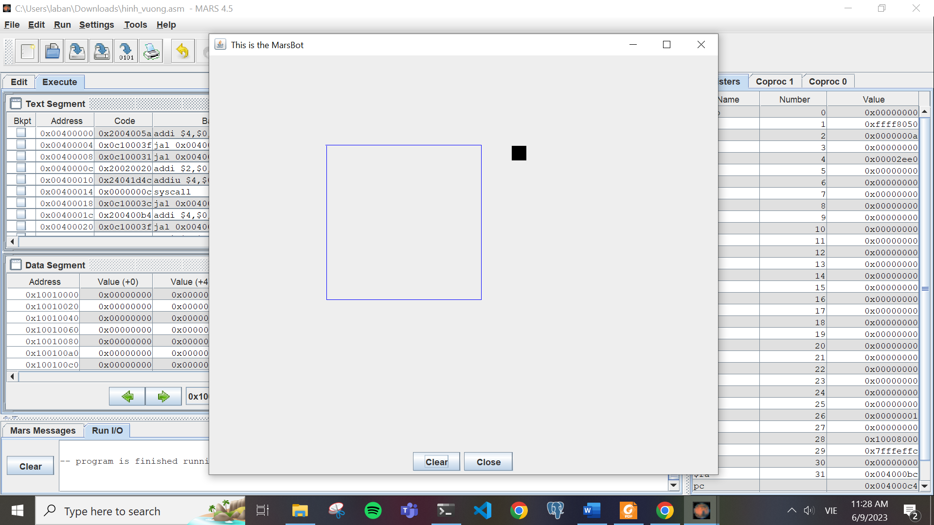

1. Vẽ ngôi sao 5 cánh:

* Code:

.eqv HEADING 0xffff8010

.eqv MOVING 0xffff8050

.eqv LEAVETRACK 0xffff8020

.eqv WHEREX 0xffff8030

.eqv WHEREY 0xffff8040

.text

main:

addi $a0, $zero, 90

jal ROTATE

jal GO

sleep1: addi $v0,$zero,32

li $a0,15000

syscall

jal UNTRACK

goDOWN: addi $a0, $zero, 180

jal ROTATE

sleep2: addi $v0,$zero,32

li $a0,8000

syscall

jal UNTRACK

jal TRACK

go120: addi $a0, $zero, 162

jal ROTATE

sleep3: addi $v0,$zero,32

li $a0,6000

syscall

jal UNTRACK

jal TRACK

go30: addi $a0, $zero, 306

jal ROTATE

sleep4: addi $v0,$zero,32

li $a0,6000

syscall

jal UNTRACK

jal TRACK

goleft: addi $a0, $zero, 90

jal ROTATE

sleep5: addi $v0,$zero,32

li $a0,6000

syscall

jal UNTRACK

jal TRACK

goL: addi $a0,$zero,234

jal ROTATE

li $a0,6000

syscall

jal UNTRACK

jal TRACK

go1: addi $a0,$zero,18

jal ROTATE

li $a0,6000

syscall

jal UNTRACK

go12: addi $a0,$zero,90

jal ROTATE

li $a0,6000

syscall

jal STOP

end_main:

li $v0,10

syscall

#-----------------------------------------------------------

# GO procedure, to start running

# param[in] none

#-----------------------------------------------------------

GO: li $at, MOVING

addi $k0, $zero,1 # to logic 1,

sb $k0, 0($at) # to start running

jr $ra

#-----------------------------------------------------------

# STOP procedure, to stop running

# param[in] none

#-----------------------------------------------------------

STOP: li $at, MOVING

sb $zero, 0($at) # to stop

jr $ra

#-----------------------------------------------------------

# TRACK procedure, to start drawing line

# param[in] none

#-----------------------------------------------------------

TRACK: li $at, LEAVETRACK

addi $k0, $zero,1

sb $k0, 0($at)

jr $ra

#-----------------------------------------------------------

# UNTRACK procedure, to stop drawing line

# param[in] none

#-----------------------------------------------------------

UNTRACK: li $at, LEAVETRACK

sb $zero, 0($at)

jr $ra

#-----------------------------------------------------------

# ROTATE procedure, to rotate the robot

# param[in] $a0, An angle between 0 and 359

# 0 : North (up)

# 90: East (right)

# 180: South (down)

# 270: West (left)

#-----------------------------------------------------------

ROTATE: li $at, HEADING

sw $a0, 0($at)

jr $ra

* Kết quả chạy:

**Assignment 2:**

* Code:

.eqv KEY_CODE 0xFFFF0004

.eqv KEY_READY 0xFFFF0000

.eqv DISPLAY_CODE 0xFFFF000C

.eqv DISPLAY_READY 0xFFFF0008

.text

li $k0, KEY_CODE

li $k1, KEY_READY

li $s0, DISPLAY_CODE

li $s1, DISPLAY_READY

loop: nop

WaitForKey:

lw $t1, 0($k1)

beq $t1, $zero, WaitForKey

ReadKey:

lw $t0, 0($k0)

WaitForDis:

lw $t2, 0($s1)

beq $t2, $zero, WaitForDis

Kiemtra:

KiemTraE:

beq $t3, 1, KiemTraX

beq $t0, 101, Co

KiemTraX:

beq $t3, 2, KiemTraI

beq $t0, 120, Co

KiemTraI:

beq $t3, 3, KiemTraT

beq $t0, 105, Co

KiemTraT:

beq $t3, 4, Encrypt2

beq $t0, 116, Co

Encrypt:

addi $t3, $zero, 0

Encrypt2:

ChuHoa: bgt $t0, 90, ChuThuong

blt $t0, 65, ChuThuong

addi $t0, $t0, 32

j ShowKey

ChuThuong:

bgt $t0, 122, ChuSo

blt $t0, 97, ChuSo

addi $t0, $t0, -32

j ShowKey

ChuSo: bgt $t0, 57, Khac

blt $t0, 48, Khac

addi $t0, $t0, 0

j ShowKey

Khac:

addi $t0, $zero, 42

ShowKey:

sw $t0, 0($s0)

nop

beq $t3, 4, Exit

j loop

Co: addi $t3, $t3, 1

j Encrypt2

Exit:

li $v0, 10

syscall

* Kết quả chạy thử:

**Assignment 3:**

* Code:

.eqv HEADING 0xffff8010

.eqv MOVING 0xffff8050

.eqv LEAVETRACK 0xffff8020

.eqv WHEREX 0xffff8030

.eqv WHEREY 0xffff8040

.eqv KEY_CODE 0xFFFF0004

.eqv KEY_READY 0xFFFF0000

.eqv DISPLAY_CODE 0xFFFF000C

.eqv DISPLAY_READY 0xFFFF0008

.text

main:

li $s2, KEY_CODE

li $s3, KEY_READY

li $s0, DISPLAY_CODE

li $s1, DISPLAY_READY

start:

WaitForKey_start:

lw $t1, 0($s3)

beq $t1, $zero, WaitForKey_start

ReadKey_start:

lw $t0, 0($s2)

beq $t0, 32, loop # dau space thi bat dau

j start #neu khong thi lap lai

loop:

WaitForKey:

lw $t1, 0($s3)

beq $t1, $zero, WaitForKey

ReadKey:

lw $t0, 0($s2)

WaitForDis:

lw $t2, 0($s1)

beq $t2, $zero, WaitForDis

Input:

InputW: beq $t0, 119, Len

beq $t0, 87, Len

InputS: beq $t0, 115, Xuong

beq $t0, 83, Xuong

InputA: beq $t0, 97, Trai

beq $t0, 65, Trai

InputD: beq $t0, 100, Phai

beq $t0, 68, Phai

j InputExit

Len:

addi $a0, $zero, 0

jal ROTATE

jal GO

jal UNTRACK

jal TRACK

addi $v0,$zero,32

li $a0,100

syscall

j ShowKey

Xuong:

addi $a0, $zero, 180

jal ROTATE

jal GO

jal UNTRACK

jal TRACK

addi $v0,$zero,32

li $a0,100

syscall

j ShowKey

Trai:

addi $a0, $zero, 270

jal ROTATE

jal GO

jal UNTRACK

jal TRACK

addi $v0,$zero,32

li $a0,100

syscall

j ShowKey

Phai:

addi $a0, $zero, 90

jal ROTATE

jal GO

jal UNTRACK

jal TRACK

addi $v0,$zero,32

li $a0,100

syscall

j ShowKey

InputExit:

beq $t0, 32, end_main

j ShowKey

ShowKey:

sw $t0, 0($s0)

nop

j loop

end_main:

jal UNTRACK

jal STOP

li $v0, 10

syscall

GO:

li $at, MOVING

addi $k0, $zero,1

sb $k0, 0($at)

jr $ra

ROTATE:

li $at, HEADING

sw $a0, 0($at)

jr $ra

STOP:

li $at, MOVING

sb $zero, 0($at)

jr $ra

TRACK:

li $at, LEAVETRACK

addi $k0, $zero,1

sb $k0, 0($at)

jr $ra

UNTRACK:

li $at, LEAVETRACK

sb $zero, 0($at)

jr $ra

* Kết quả chạy thử:

